**A proposed technique for determining “quasi-instantaneous” outflow facility**

**Reza Bahrani Fard, Wei Zhu and C. Ross Ethier**

**May 27, 2020**

# Problem statement

The iPerfusion system computes aqueous outflow facility from steady values of flow and pressure at each step in a series of pressure steps. This works well for assessing the effects of a long-duration drug or of a long-duration alteration in outflow function. However, suppose that we wish to interrogate a “fast-acting” pathway in the TM, e.g. one that adjusts facility rapidly in response to an external stimulus, such as a change in IOP. This is more challenging, since any transient pressure-flow response of the eye involves both the “fast” change in facility that we wish to understand, as well as the effects of ocular compliance. Below we present a framework for determining such “fast” facility changes from transient pressure-flow data gathered by the iPerfusion system.

# Methods

*General equations:* Figure 1 shows the equivalent electrical circuit for the iPerfusion system attached to an eye.

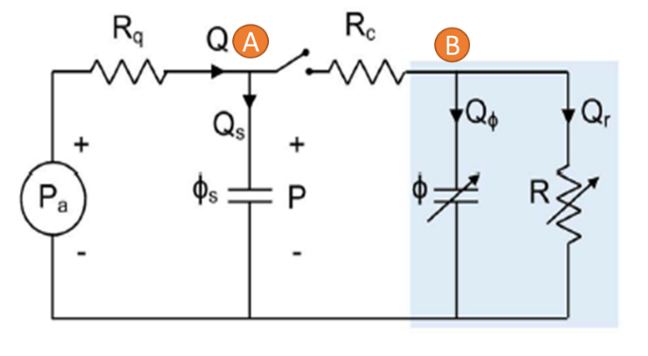

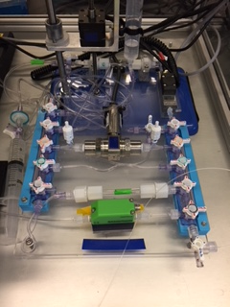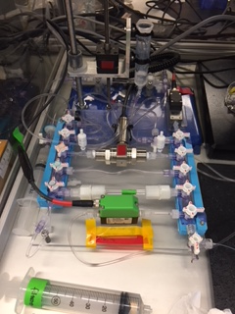

Figure . Equivalent electrical circuit for iPerfusion system (top) and photos of the actual system.

To derive the governing equations, we write Kirchhoff’s law of currents for the nodes A and B.

Writing currents for node (A):

Eq. 1

Note that the term can be replaced by the flow sensor reading () when the above equation is solved numerically. For node (B):

Eq. 2

Equations 1 and 2 are the governing equations of the circuit in Fig. 1 in which and are conductances of flow sensor and the needle, respectively. From Eq. 1 IOP can be calculated by:

Eq. 3

And the time derivative of IOP becomes:

Eq. 4

An alternative to analytically calculating the time derivative of IOP is numerical differentiation of the IOP signal, obtained directly from Eq. 3.

To simplify and reduce the amount of noise in calculations, we consider the situation in which the needle resistance is much smaller than the flow sensor resistance, so that needle resistance can be neglected. Thus, points A and B will “merge” and we obtain a single governing equation:

Eq. 5

Please note that and are both non-constant.

*Instantaneous linear fitting:* Since we have 1 equation with two unknowns, we need to find a way to separate these two variables. To do so, we write Eq. 5 as:

**Eq. 6**

Eq. 6a

Eq. 6b

Although and are not constant in Eq. 6, if we consider a short interval of samples their variation can be neglected. Therefore, by plotting vs. we expect to obtain a graph with outflow facility as the slope and ocular compliance as the y-intercept.

Equation 6 is derived using the assumption that needle resistance is negligible compared to flow sensor resistance. However, if this were not the case Eq. 2 could be rewritten as:

Eq. 7

While we used no assumption to derive Eq. 7, we now make 3 assumptions to simplify our fitting approach.

1. From Eq. 1 we have . Our calculations show that the term is in most cases negligible compared to .
2. In most cases, the difference between and is small (less than 5% difference). As a result, can be replaced by .
3. In Eq. 4, can be neglected compared to .

As a result of these simplifications Eq. 7 becomes:

**Eq. 8**

Eq. 8a

Eq. 8b

Eq. 8c

*Derivative calculations and sampling:* Derivatives of and with respect to time are calculated numerically. To do so, we use a simple first order differencing scheme, i.e. the difference between two subsequent samples is divided by the time interval between the samples. Then, the first element of time derivative vector is assigned to the first element of quantity that is being differentiated. Figures 2 and 3 show values of flow rate and pressure for a control eye from Liz’s experiments.

A Savitzky-Golay filter with first order regression was used to smooth , , and . The length of the filter was 0.6 second which corresponds to 12 data points. The blue curves in Figures 2-4 represent the filtered data.

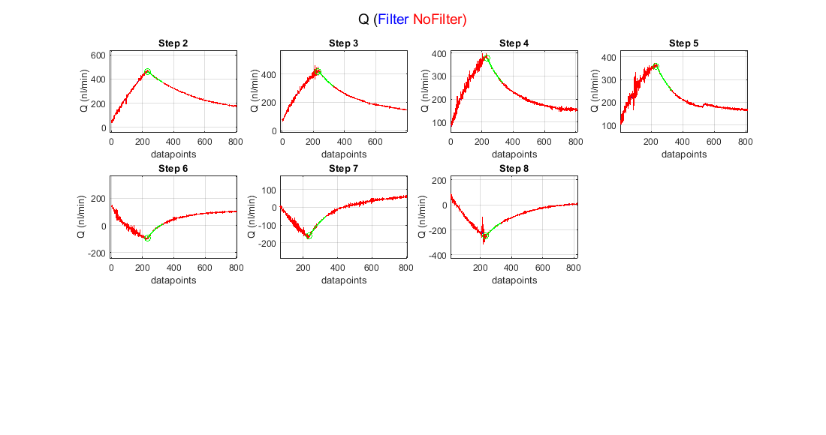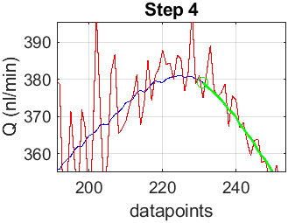

Figure . Flow rate plots for each pressure step for perfusion of one mouse eye. Green shows the interval chosen for the analysis. Small box shows zoomed-in region to magnify the filtered vs. non-filtered data. Data point zero is in this graph and subsequent figures is the instant when the actuator begins to move, as determined by the output voltage from the actuator. Similarly, the green circle shows when the actuator stops moving, as determined by the output voltage from the actuator.

*Point-wise compliance calculation:* To determine ocular compliance over time we can rearrange Eq. 6 to write:

was taken as the value of the slope of the fitted line in Eq. 6.

*Validation with system compliance experiment:*  One way to validate our approach is to perfusing a compliant chamber with no outflow, which allows us to set . Experiments in which we measure system compliance are suitable: we close all outflow routes and perfuse the tubing of the system. If our approach is correct, the values for system compliance should be the same as those computed by Joseph’s discrete volume method. In such an experiment, equation 5 can be rewritten as:

Eq. 9

By calculating and , system compliance can be calculated. However, when we carried out this calculation, an unexpected non-zero flow rate on the order of 5 nl/min was observed in the steady state region where flow rate should be zero. We suspect this is due to a small leak or to limitations of the flow transducer. To overcome this effect, we averaged this steady state flow rate () and subtracted the average value from the flow rate data.

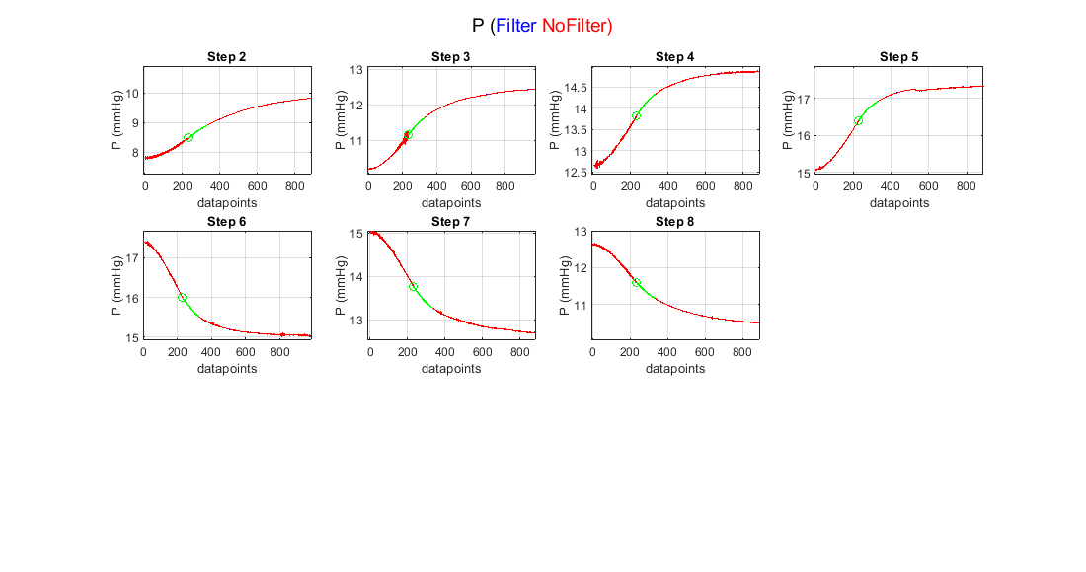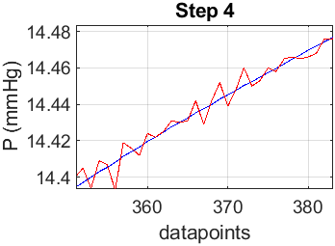

Figure . Pressure plots for each step of perfusion in one eye. Green shows the interval chosen for the analysis. Small box shows zoomed-in region to magnify the filtered vs. non-filtered data.

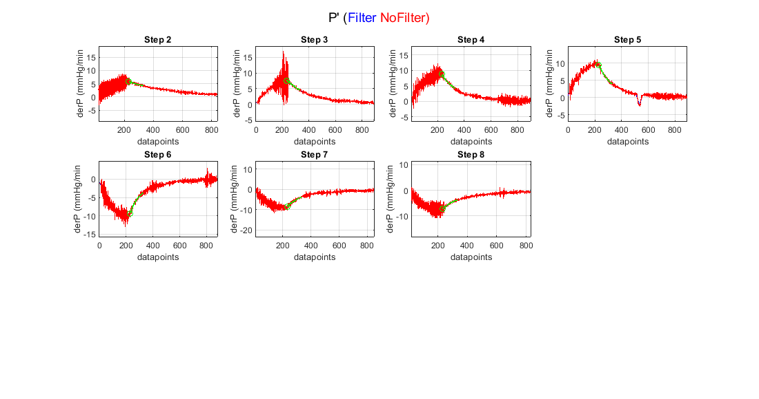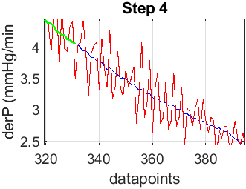

Figure . Time derivative of pressure plots for each step of perfusion in one eye. Green shows the interval chosen for the analysis. Small box shows where zoomed in to magnify the filtered vs. non-filtered data.

In this experiment, all the flow rate goes into system compliance therefore:

*Outflow facility plots:* Transient outflow facility was calculated by the slope of Eq. 6. Steady-state facility was calculated and fitted using Joseph’s power law model.

*Needle resistance (only for Eq. 8): This section will be added after reassuring the method.*

# Results

A control eye from a wild-type C57BL/6 mouse from Liz’s experiment was selected as representative. In this experiment, pressure ranged from 5 to 17.5 mmHg with each step having a pressure change of 2.5 mmHg. Since the capillary upstream of flow sensor was in the system in these experiments, the response of system was low. Therefore, I chose a period of 100 data points (5 seconds) after the actuator stopped to be fitted with the linear model in Eq. 6 ( was negligible compared to ). Figure 5 shows the plot of vs. and the corresponding fitted equation. For step 3, from the slope of this equation and from the y-intercept .



Figure . Plot of vs. according to Eq. 6. The slope of the graph in the green region is the instantaneous outflow facility, while the y-intercept of the regression line is ocular compliance. The green region is the interval chosen for linear fitting.

Using the values of calculated from Fig. 5, point-wise compliance was calculated (Fig. 6).

Figure 7 shows the transient (calculated by Eq. 6) and steady-state (Joseph’s Discrete Volume method) outflow facilities. At some pressures, two values for outflow facility can be observed and that is because in this dataset we have up-ramping and down-ramping pressure steps.

A system compliance experiment was used to validate our method. Figure 8 shows the resulting plots from system compliance analysis method (plots) and Joseph’s discrete volume method (bold black equations on each plot).



Figure . Point-wise ocular compliance. Green circle denotes the data point where actuator stops moving.

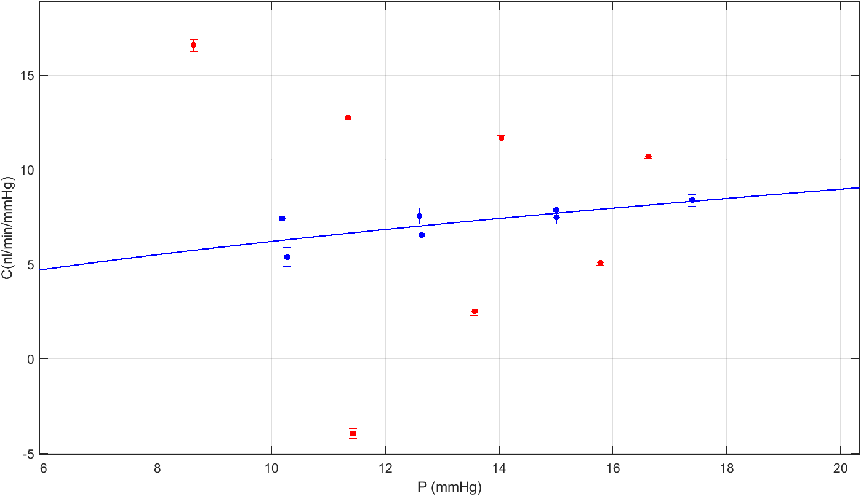

Figure . Transient and steady-state outflow facility. Each point is the outflow facility for one step. Red is the transient response facility (calculated by Eq. 6) and blue is the steady state facility value.



Figure . System compliance calculated using instantaneous method for each pressure step of a system compliance experiment. Compliance values in bold black text are calculated using Joseph’s discrete volume method. Selected data points show the compliance value at selected times. Green filled circle shows where the actuator stops.

# Major unresolved problems

We observe a sudden increase in calculated values of system compliance after the actuator stops moving (Fig. 8). This corresponds to the point where dP/dt starts to decrease (Fig. S1.3). This issue can be translated into our instantaneous outflow facility measurement since in this analysis we have changing pressure time derivative both while actuator is moving and when it stops (compare Fig.4 with Fig. S1.3).

# Supplementary

Part 1.Additional plots for the data analyzed in this report are provided here. This part is for Liz’s experiments.

Figure S1.1. and S1.2 show plots for and vs. time for each pressure step.

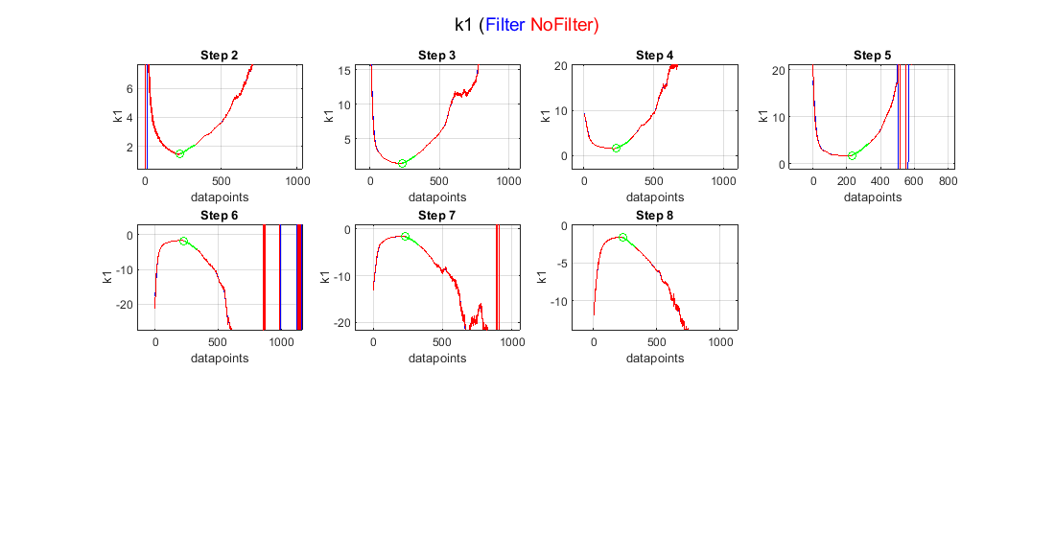

Figure S1. Time traces for quantity from Eq. 6.

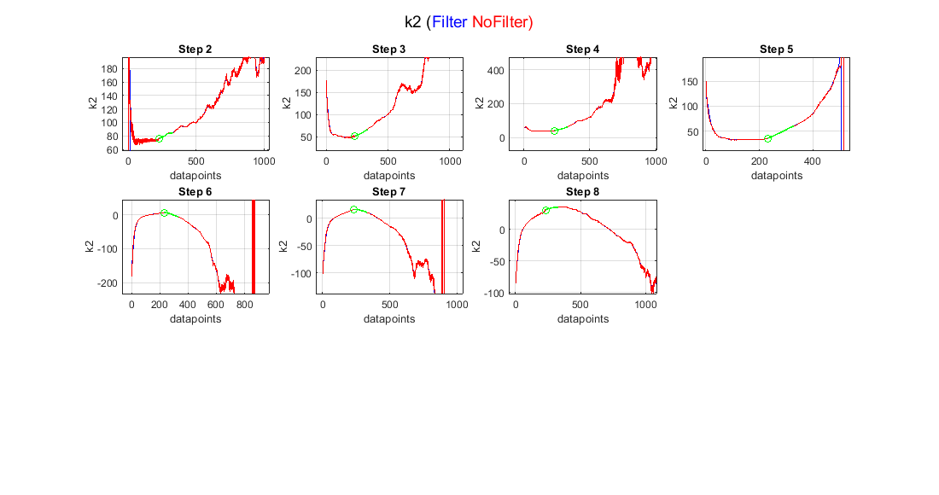

Figure S1. Time traces for quantity from Eq. 6.

Figure S1.3. Time derivative of pressure for system compliance experiment.

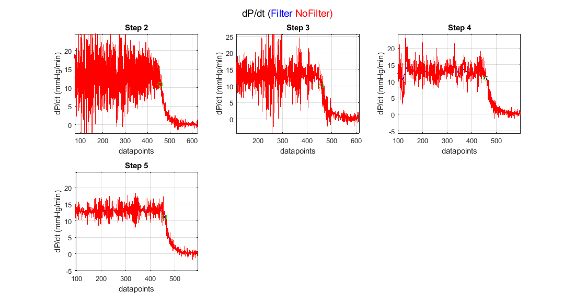

Figure S1. pressure time derivative plot for system compliance experiment. Green circle shows the actuator stop point.

Part 2.In this part, same analysis in the report is presented for a control eye from Wei’s experiments with 4.5 – 16.5 mmHg pressure range. Please note that because in this data the capillary upstream of flow sensor is not present, system response quickly becomes reaches steady state and thus a shorter time interval is considered for calculations. This period is about 30 data points which is 1.5 second of experiment after actuator stops.

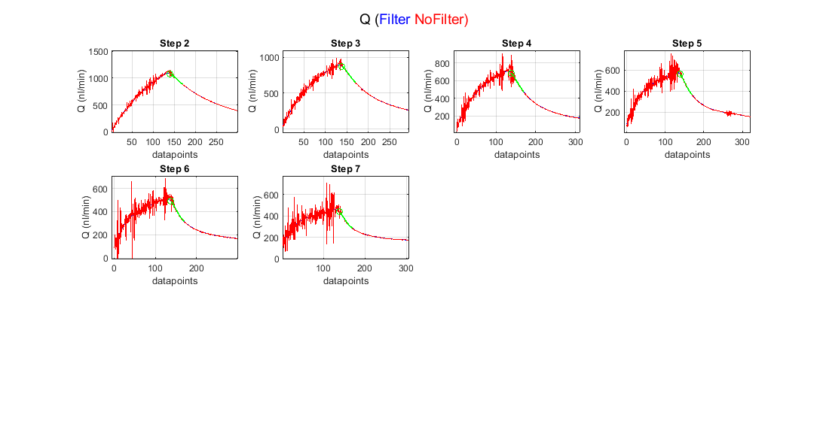

Figure S2. Flow rate plots for each step of perfusion in one eye. Green shows the interval picked for the analysis. Small box shows where zoomed in to magnify the filtered vs. non-filtered data.

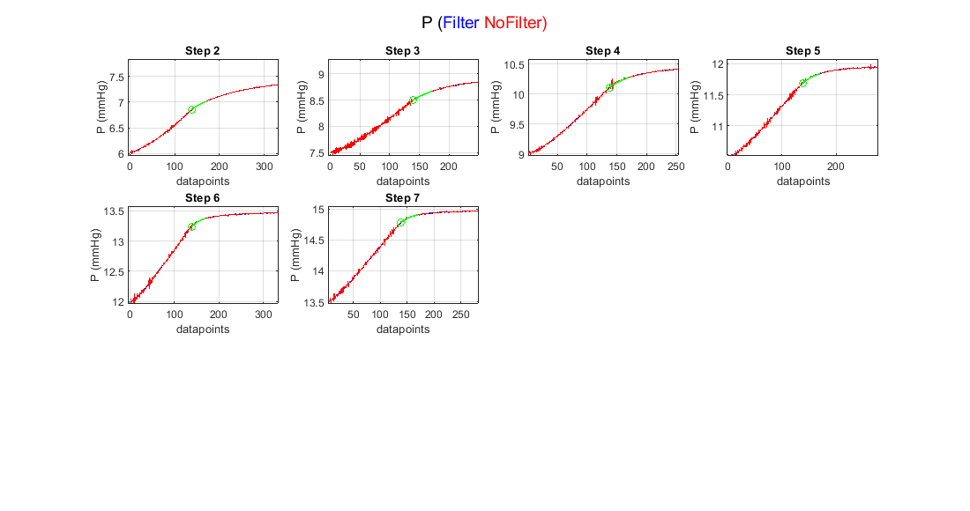

Figure S2. Pressure plots for each step of perfusion in one eye. Green shows the interval picked for the analysis. Small box shows where zoomed in to magnify the filtered vs. non-filtered data.

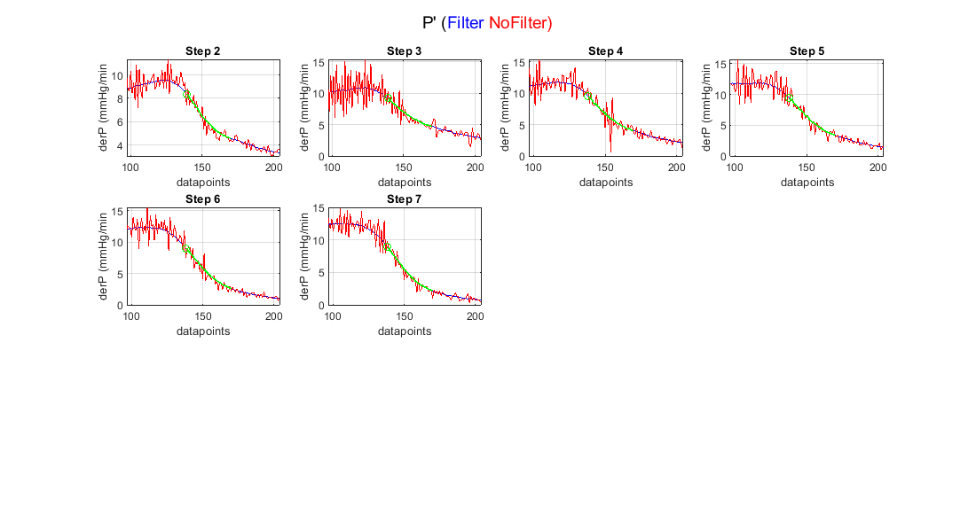

Figure S2. Pressure time derivative plots for each step of perfusion in one eye. Green shows the interval picked for the analysis. Small box shows where zoomed in to magnify the filtered vs. non-filtered data.

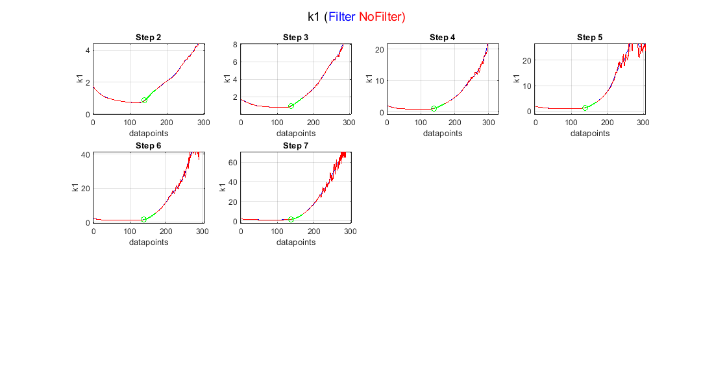

Figure S2. time traces for k1 quantity from Eq. 6.

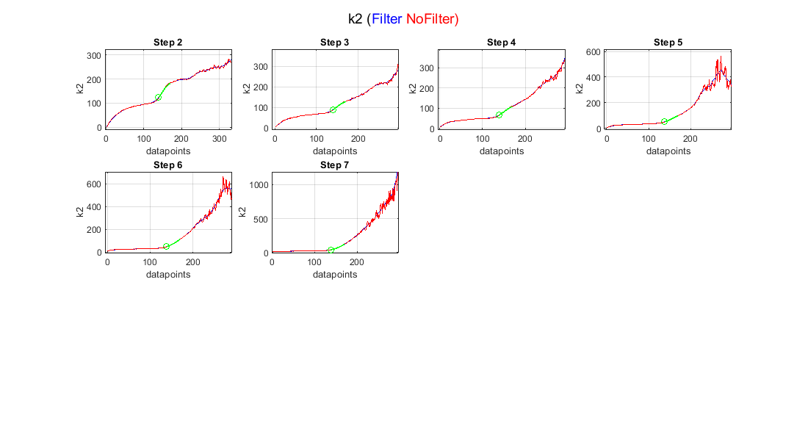

Figure S2. time traces for k1 quantity from Eq. 6.



Figure S2. Plot for Eq. 6. Slope of the written equation is instantaneous outflow facility and y-intercept is ocular compliance. Green shows the chosen interval for linear fitting.

In Figure S2.6, the instantaneous outflow facilities at initial steps are unexpectedly high. Since in this data the capillary upstream of flow sensor is not in the circuit, needle resistance can play a role. After verifying the assumptions mentioned in Methods section under *Instantaneous linear fitting* we can use Eq. 8 to account for needle resistance. Plots S2.7 and S2.8 show the validity of these assumptions. As confirmed by these plots, Eq. 8 can be used to plot k2N vs. k1N quantities (Fig. 2.9). Values of instantaneous facility are lowered in this plot compared to Fig. S2.6.

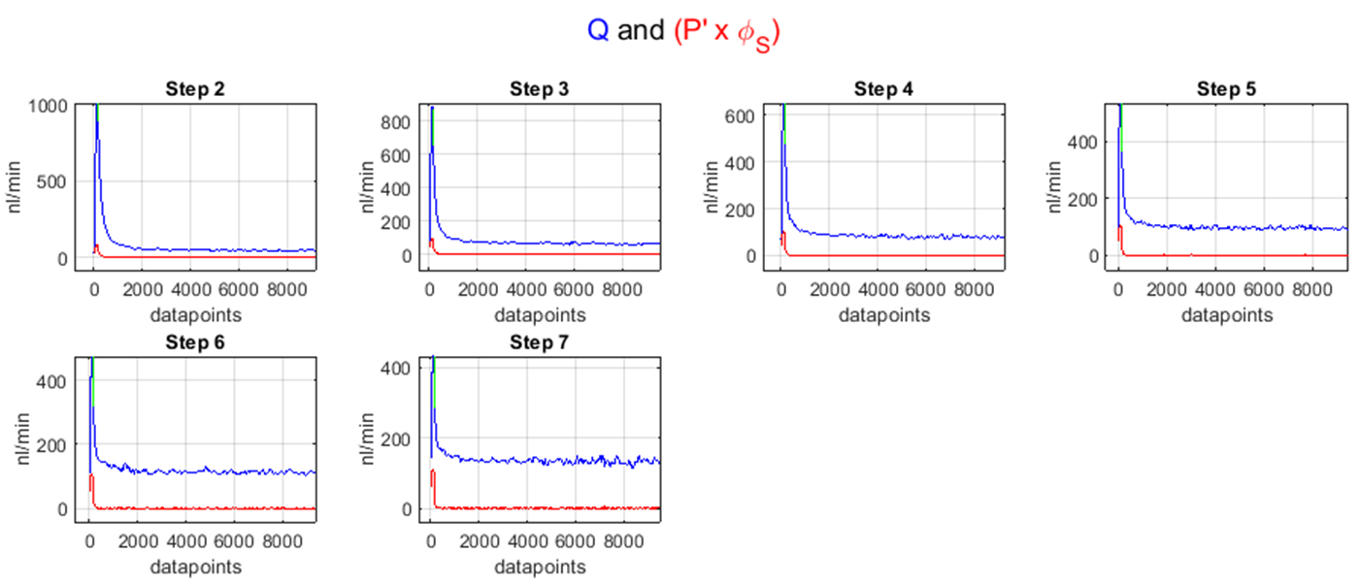

Figure S2. Plot of Q and to confirm the negligibility of later compared to former.

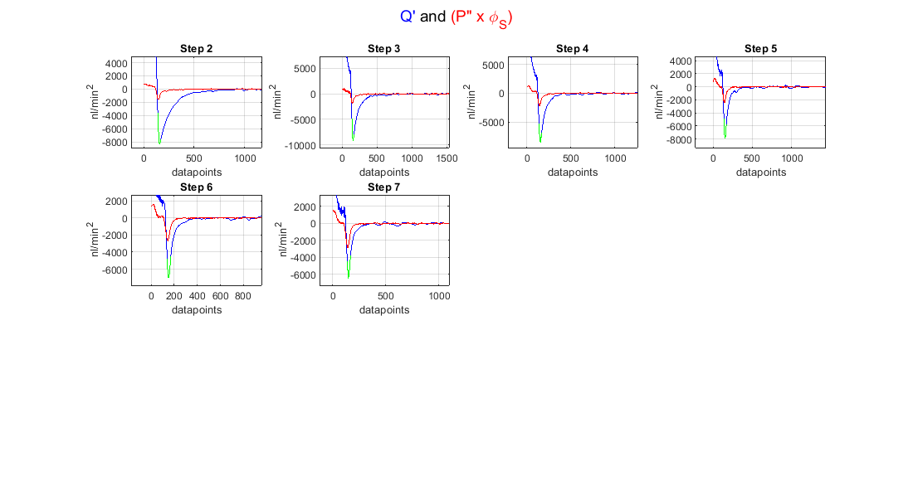

Figure S2. Plot of and to confirm the negligibility of later compared to former.



Figure S2. Plot for Eq. 8. Slope of the written equation is instantaneous outflow facility and y-intercept is ocular compliance. Green shows the chosen interval for linear fitting